Nitrogen and Irrigation Treatment Optimization (NITRO) Project

Dr. Neil Hansen and Dr. Bryan Hopkins

Project background:

Due to water scarcity and drought in many regions, landscape irrigation limits have been set to conserve water. Drought conditions have created a need to understand how to manage a limited water supply to maintain turf health and function. Even in regions where turf is not commonly irrigated, there is a need to manage turf for tolerance to dry periods. The importance of nutrient management and its relationship to turf water use and drought tolerance is often overlooked. For example, application of excessive nitrogen fertilizer is common in landscape turf settings. Excess nitrogen increases rates of growth and water use and simultaneously reduces root development, both of which make turf more vulnerable to drought. Nutrient deficiencies can also be problematic when drought occurs because plants are already experiencing abiotic stress and are less able to tolerate drought conditions. Thus, nutrient management decisions indirectly have water management effects.

One goal of the BYU Turf grass research program is to study ways to optimize the supply of water and nitrogen (Hopkins et al., 2008). Another objective is to evaluate the potential application of soil water sensors and/or remote canopy sensors to improve irrigation and fertilizer decisions.

Study Site

Construction of a turf irrigation research facility was initiated outside of the BYU research greenhouse in the fall of 2016 and Kentucky blue grass (species) was established in the summer of 2017. The facility consists of 27 individual research plots (3.4 m x 3.4 m), divided in a randomized, complete block design among three irrigation zone treatments. Irrigation treatments are deficient, optimum, and excessive. Within each irrigation treatment, there are three nitrogen levels, each replicated three times. Nitrogen fertilizer treatments are deficient, optimum, and excessive rates.

Sensor Description

Water content sensors. Water content sensors indicate the volumetric water content (VWC) in the soil. Each individual research plot has a single soil water content sensor installed at a depth of 6.4 cm below the soil surface. In addition to the GS3 sensors located in each plot, three plots (403, 503, and 603) have been instrumented with GS3 sensors at additional depths of 15 cm and 30 cm. The Decagon GS3 sensors reports the percent volumetric water content, electrical conductivity, and soil temperature every hour.

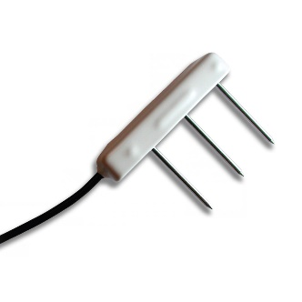

Water potential sensors. Water potential sensors indicate the relative plant availability of water in the soil. Values near the sensor maximum value of -9 kPa indicate the soil is saturated. AS the soil dries, water potential becomes increasingly negative, with plant stress for Kentucky Bluegrass begin around – 250 kPa. Three plots (403, 503, and 603) have been instrumented with Decagon MPS6 soil water potential sensor three depths (6.4, 15, and 30 cm). These sensors report soil water potential and soil temperature every hour.

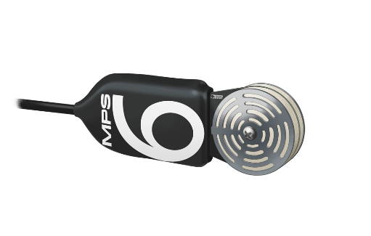

Spectral reflectance sensors (SRS-Nr NDVI). Decagon SRS-Nr NDVI sensors were installed on 5/24/2017 by mounting the sensors on poles adjacent to the southern-most row of 9 plots. These sensors measure reflected light in the 630 nm and 800 nm visible wavelengths and use these values to calculate the normalized differential vegetative index (NDVI). The NDVI is an indicator of the greenness of the canopy and ranges from 0 to 1. Values our measured every hour, but NDVI is only calculated during daylight hours.

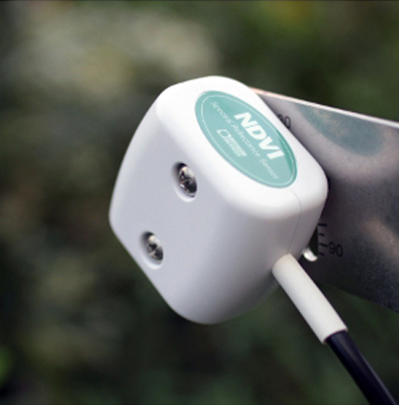

Infrared Radiometeres (SI-411). Infrared radiometers are sensors that measure the temperature of a target surface by measuring the flux of infrared radiation. The SI-411 sensors were installed on 9/19/2017 by mounting the sensors on poles adjacent to the southern-most row of 9 plots. The sensors give hourly data of the target and sensory (body) temperatures.

Data Loggers

All field sensors are connected to Decagon EM50G dataloggers located in the field. Each data logger has input ports for up to 5 sensors. Thus, to accommodate all of the sensors used in the study, the study uses a total of 13 loggers (plus one for the weather station not described here). The loggers transmit the data via cellular model to the company Decagon, which then makes the data available through an internet based server. The data is downloaded in separate files for each logger. A sepeate file with diagrams that name and identify the dataloggers and the corresponding sensors is provided.

Fall 2017 Dry-down experiment

Data is available for sensors from the time they were installed, but we are most interested in the data during a dry-down experiment conducted from 9/23/2017 to 10/16/2017. Only during this time were the irrigation and nitrogen fertilizer treatments implemented. Additional dry-down periods will be conducted in 2018. In reality, it was not a great time for a dry-down because the late fall temperatures were cool, days were short, and there were several rain events. My initial scan of the soil sensor data suggests almost no significant drying. There may be some differences in the NDVI and canopy temperature.

Objectives for the Bioinformatics Project

The objective of this bioinformatics project is to create annotated R code that can be used for current and future NITRO datasets to aggregate multiple data files, visualize soil and plant conditions over time, identify time periods where stress occurred, and generate descriptive statistics that compare experimental treatments.

Potential List of Specific Tasks for the Bioinformatics Project

1. Write an R script that can utilize data that comes from 13 individual data files (one for each of the data-loggers) for analysis and graphing. This may be challenging because there will be identical column headings in multiple files. The script will need to identify the columns with the corresponding plot ID
2. Generate line charts for soil sensors in plots 403, 503, and 603 (time vs VWC; time vs kPa). Make separate charts for each depth and sensor type, and each chart with three lines, one for each turf plot (403, 503, and 603).
3. Generate time vs treatment average VWC line charts. These will use treatment averages from the VWC sensors found in all 27 plots. The lines will each represent a irrigation treatment average VWC. Make separate charts for each nitrogen treatment level.
4. In there are days where variation in AWC is apparent in #3, generate an analysis of variance for average daily AWC on specific days of interest.
5. Generate time vs NDVI line charts. Each line will represent one of the 9 instrumented plots. Line plots that compare nitrogen treatments with separate charts for each irrigation treatment level.
6. Generate time vs canopy temperature line charts. Each line will represent one of the 9 instrumented plots. Line plots that compare average of irrigation treatments.